**[Week 08 DQ1 Assignment](https://elearning.uol.ohecampus.com/webapps/blackboard/content/launchLink.jsp?course_id=_1434683_1&content_id=_5960340_1&mode=view)**

By Fatai Oseni

Introduction:

The assignment has to do with developing an application using example given in Figure 8-1 )in the lecture note), the new application should display one out of a possible 10 pictures in the window and users should be able to choose the picture by position tick on the Slide bar.

To achieved these, there were two classes namely Week8DQ1Assignment which is driver class and SliderDisplayImage. In SliderDisplayImage class, that displays the image as user moves the slider within 0 and 10. The String array was declared to handle 10 images name and the images were located at the root directory of the application.

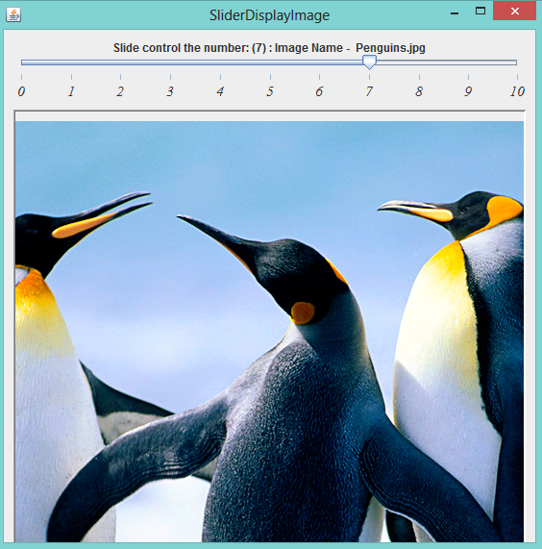

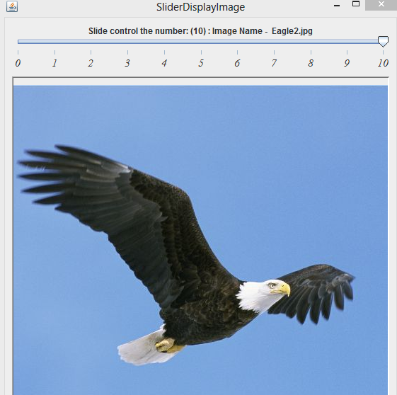

Reference:

Deitel, P. and Harvey D.(2012) “ *Java How to Program,( 9th Edition)”*